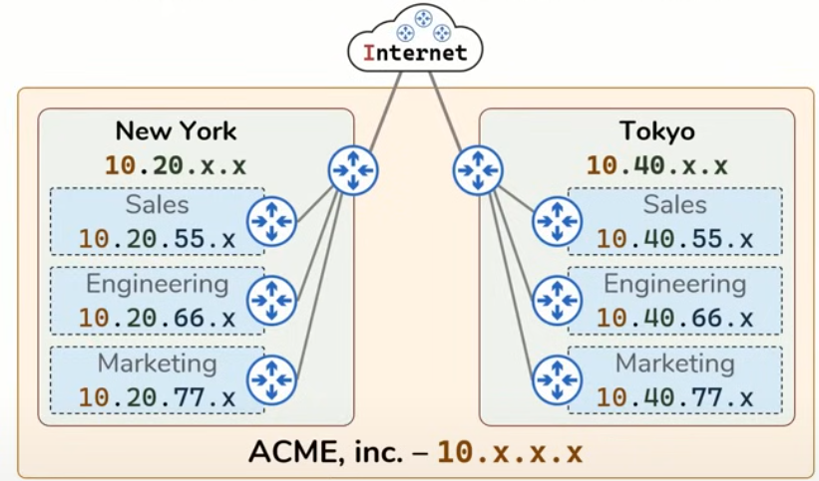

If a host from New York sales team wants to send data to a host in the engineering team in New York, the host would send the data to the routers default gateway, then the router would go through to the router of its network, then it will send it to the router in the engineering team of its network then it will send it to the host

If a host from New York sales team wants to send data to a host in the marketing team in the Tokyo network, the host would send the data to the routers default gateway, then the router would go through to the router of its network, then the data would be sent from the router of its network to the internet, then the internet would send the data to the router in the Tokyo network, then the router from the Tokyo network would send the data to the router in the marketing team, then the router from the marketing team would send it to the host